CS106 - Assessment 2

Contents

❖ Project Description 2

❖ System Modelling 2

❖ Project Implementation Screenshots 3

❖ Project Functionality Testing 3

❖ Installation Guide 4

❖ My Learning Experience Summary 5

❖ Presentation 5

❖ References 6

❖ Project Description

To create a Covid Tracing app, with appropriate accessibility / management available at user level, and administrator level. All information is to be behind a log in – either admin or user. A QR code should show a user their own test / vaccination record. (Used for verification purposes by other businesses). Lastly, users should be able to download vaccination and COVID-19 test certificates.

❖ System Modelling

- System architecture

1. Users should be able to create a new account or log into the system.
2. The Administrator should be able to log in to the system.
3. The Administrator should be able to view and modify users' information.
4. The Administrator should be able to upload and maintain users' documents.
5. After logging in, users should be able to view their details in the system.
6. After logging in, users should be able to view their COVID-19 tests and vaccine records.
7. All users should get a unique QR code and logged in users should be able to view their unique QR code for entry requirements.
8. Users should be able to report issues they would encounter in the system.
9. The system should log messages in three different files for the following:
10. When certificates are uploaded.
11. When the test results are uploaded.
12. When users report issues.
13. A “Vaccination Status” should be changed according to the number of doses the user has

received:

1. Unvaccinated
2. Partial
3. Completed

People support the simple and clean design that was originally planned, so we can keep this simplicity. The colour scheme was also appreciated however, some feel it hasn’t been used to its full potential. This can be improved upon by utilizing the current button design more frequently, instead of using text links. More information can also be shown as some think removing information for simplicity makes it feel more complex.

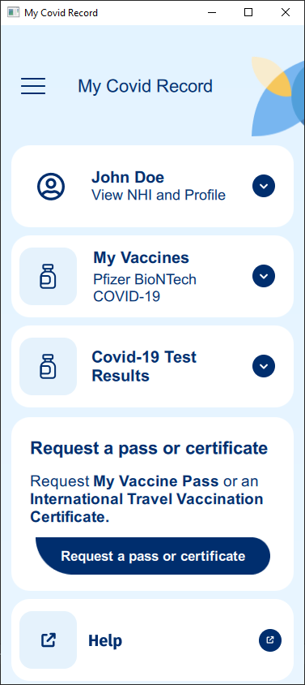❖ Project Implementation Screenshots

❖ Project Functionality Testing

- Overview of Black Box testing process

- Documentation of test cases

- Results of documented test cases along with corresponding screenshots of test output

❖ Installation Guide

To run the application executable, go to: “My Covid Record Executable\MyCovidRecord.exe” from the folder given for the assessment submission.

1. Put the unzipped folder “My-Covid-Record” into any path

(I will be using “C:\My Covid Record\My-Covid-Record” as the example directory”

1. Open “QT Creator”
2. In the “Welcome” tab, press “Open Project”
3. Go to “C:\My Covid Record\My-Covid-Record\MyCovidRecord\CMakeLists.txt” and click “Open”
4. Then go to the “Projects” tab, press on the “Build” button
5. Press “Browse…” and change the “Build directory:” to “C:\My Covid Record\My-Covid-Record\build-MyCovidRecord-Desktop_Qt_6_4_0_MinGW_64_bit-Debug” and press “Select Folder”
6. Then go back into File Explorer and navigate to “C:\My Covid Record\My-Covid-Record\build-MyCovidRecord-Desktop_Qt_6_4_0_MinGW_64_bit-Debug”
7. Find “CMakeCache.txt” and “CMakeCache.txt.prev” and delete them both.
8. Go back to QT Creator and go to the “Edit” tab
9. Right click on the root folder “MyCovidRecord” (in my case “MyCovidRecord [main]”)
10. Click on “Run CMake”
11. To test if everything works. In QT Creator in the “Edit” tab and navigate to:

qml.qrc --> / --> application.js

1. Edit “var title = “My Covid Record” to “var title = “Test”
2. Save, then run the application
3. If the window is titled “Test” everything has been setup correctly, however if the windows title is “My Covid Record” make sure you have done steps 5 – 15 properly.
4. Once everything is setup correctly change the “var title = “Test” back to “var title = “My Covid Record”

❖ My Learning Experience Summary

At first, I used QT Design Studio, which taught me the language of QML quickly. From there I was able to move to QT Creator and write the code manually. And was able to add more interactions and functionality to the application.

However, I couldn’t quite grasp how to make databases and advance application functions using JavaScript.

❖ Presentation

- Explanation of app design

- Final UI/UX explanation and usability testing feedback

- Demonstration of working application and explanation of each functionality

- Discussion of any flaws or faults that you found while coding

- Project implementation issues and challenges

## ❖ References

**There are no sources in the current document.**